**DAILY ONLINE ACTIVITIES SUMMARY**

|  |  |  |  |  |  |  |  |  |
| --- | --- | --- | --- | --- | --- | --- | --- | --- |
| **Date:** | **20/07/2020** | | | | | **Name:** | **Katira Krishna J** | |
| **Sem & Sec** | **8th A** | | | | | **USN:** | **4AL16CS045** | |
| **Online Test Summary** | | | | | | | | |
| **Subject** | | **-** | | | | | | |
| **Max. Marks** | | **-** | | **Score** | | | **-** | |
| **Certification Course Summary** | | | | | | | | |
| **Course** | **Statistics 101** | | | | | | | |
| **Certificate Provider** | | | **Cognitiveclass.ai** | | **Duration** | | | **6 hours** |
| **Coding Challenges** | | | | | | | | |
| **Problem Statement: Python program to implement counting sort** | | | | | | | | |
| **Status: Completed** | | | | | | | | |
| **Uploaded the report in Github** | | | | | **Yes** | | | |
| **If yes Repository name** | | | | | **Krishna_Katira** | | | |
| **Uploaded the report in slack** | | | | | **Yes** | | | |

Online Test Details:

No test conducted

Certification Course Details:

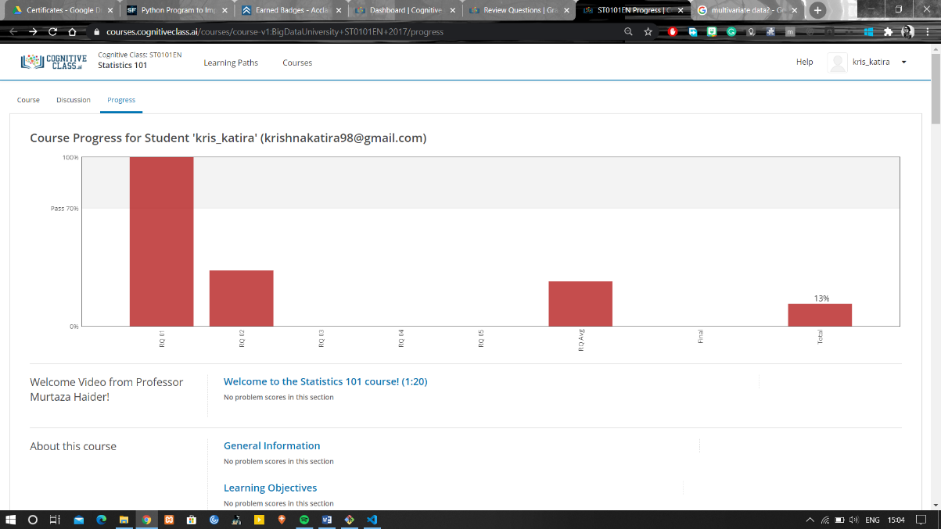

Coding Challenges Details:

**Program:**

def counting_sort(alist, largest):

c = [0]*(largest + 1)

for i in range(len(alist)):

c[alist[i]] = c[alist[i]] + 1

# Find the last index for each element

c[0] = c[0] - 1 # to decrement each element for zero-based indexing

for i in range(1, largest + 1):

c[i] = c[i] + c[i - 1]

result = [None]*len(alist)

# Though it is not required here,

# it becomes necessary to reverse the list

# when this function needs to be a stable sort

for x in reversed(alist):

result[c[x]] = x

c[x] = c[x] - 1

return result

alist = input('Enter the list of (nonnegative) numbers: ').split()

alist = [int(x) for x in alist]

k = max(alist)

sorted_list = counting_sort(alist, k)

print('Sorted list: ', end='')

print(sorted_list)